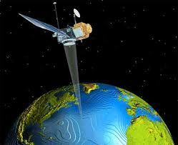
Benha University
Faculty of Engineering _Shoubra
Surveying Engineering Department
Fourth Year
Year: 2017/2018
Semester: One
Remote Sensing and Photo Interpretation
Assignment No: 5

Image Enhancement
- What is meant by Image Contrast?
- Types of Stretching image histograms.
- Define the following terms:
- Filters.
- Moving average filter.
- High Pass Filters (HPF).
- Low Pass Filters (LPF).
- Edge detectors.
- Convolved image.
- Apply Moving Average Filter and Sobel operator to the window given in table below. Show the obtained results in each case.
C1 | C2 | C3 | C4 | C5
9 | 13 | 5 | 10 | 13 | R1
12 | 17 | 12 | 9 | 8 | R2
11 | 24 | 10 | 8 | 11 | R3
9 | 15 | 13 | 15 | 14 | R4
12 | 18 | 17 | 20 | 19 | R5

- Discuss the spatial filtering techniques used to enhance the acquired satellite images.

